Sort Using Selection Sort

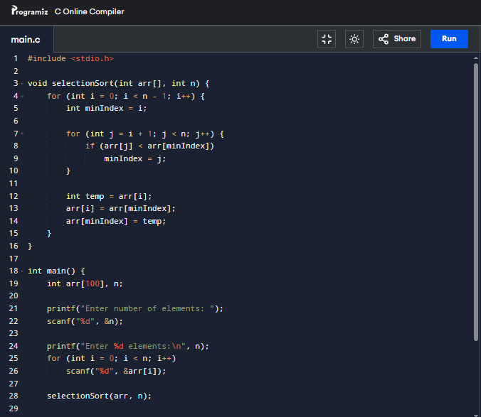

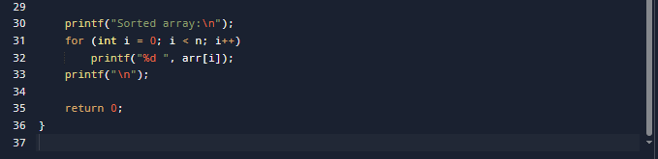

Program Output

